- Create a Markdown cell that includes your studentID and the date.

- Create a histogram to visualize the distribution of HDI scores across countries.
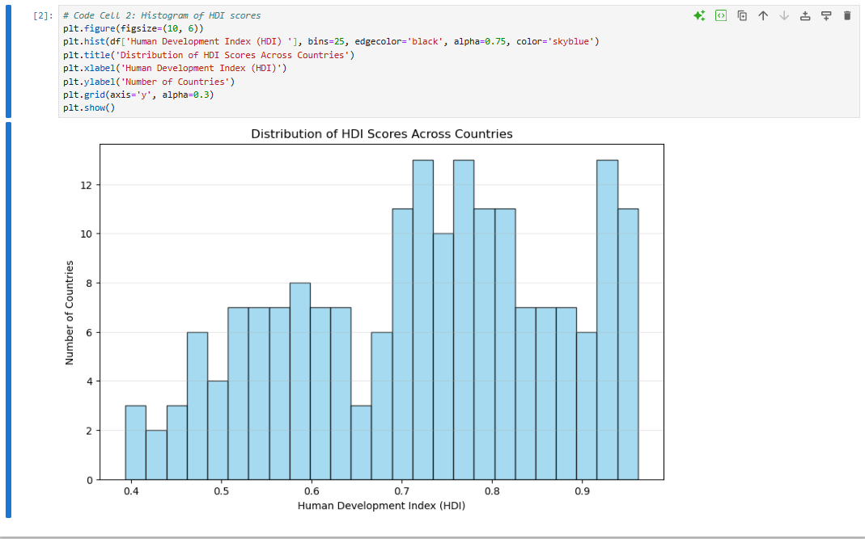
- Construct a bar chart to display the top 10 countries with the highest HDI scores.
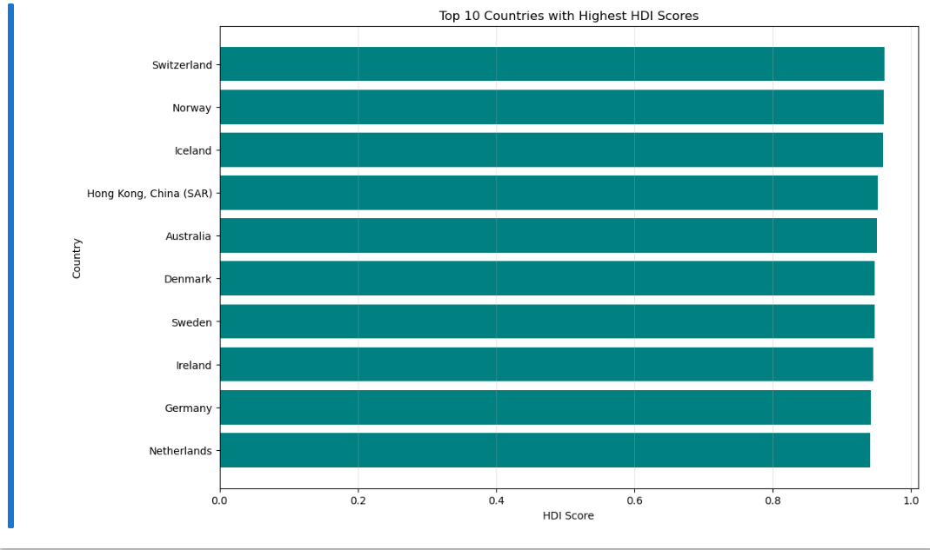
- Generate a scatter plot to visualize the relationship between "HDI" and "Gross national income (GNI) per capita."
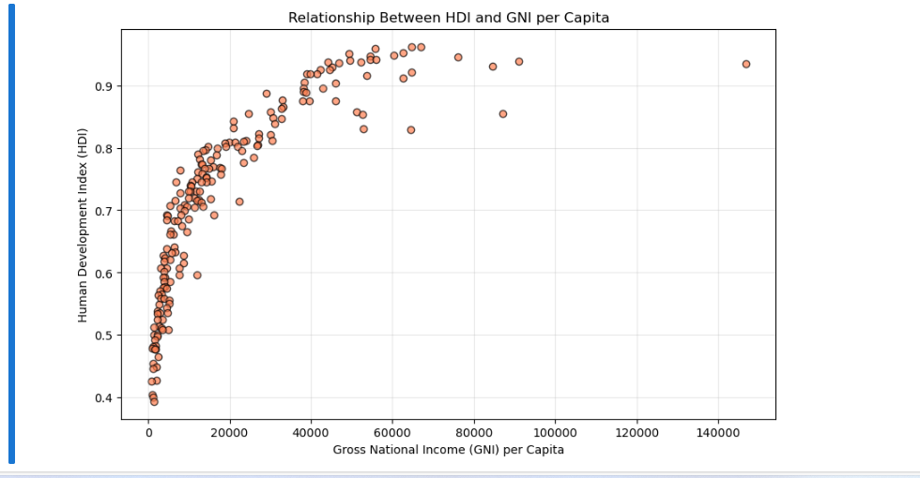
- Create a heatmap to show the correlations of HDI with the other numerical variables.
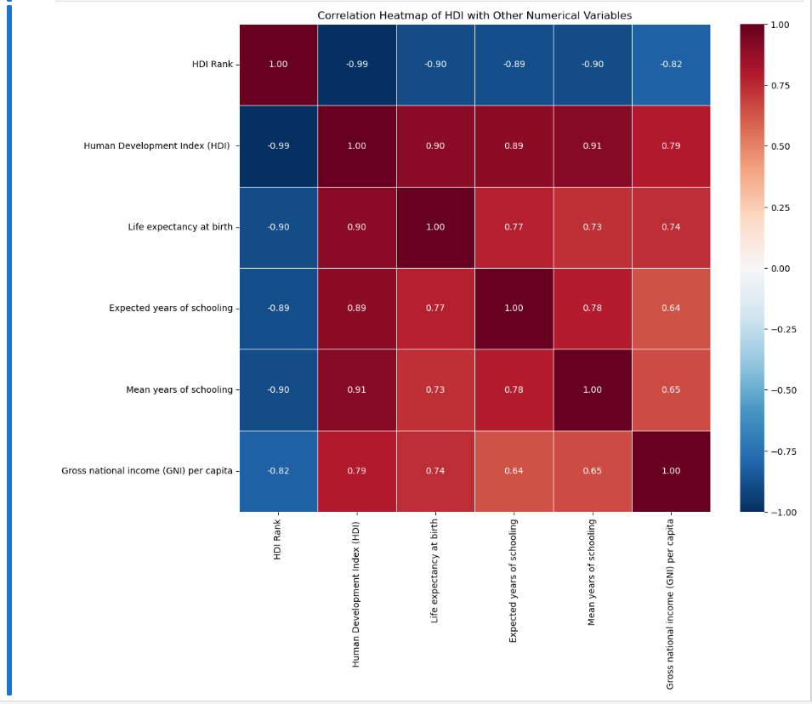

- Answer the following questions in Word document:
  - What does the distribution of HDI scores across countries look like based on the histogram? Are there any noticeable peaks or clusters?
The distribution of HDI scores is unimodal and slightly right-skewed (longer tail toward lower values), with a clear peak (mode) around 0.70 - 0.80. There is a noticeable cluster of high-HDI countries (0.85 - 0.96) representing developed nations, a large central cluster of medium-HDI countries (0.60 - 0.85), and a smaller tail of low-HDI countries (below 0.60) for the least developed nations. This reflects global inequalities in development.

  - Which countries are among the top 10 in terms of HDI scores?
• Switzerland (0.962)
• Norway (0.961)
• Iceland (0.959)
• Hong Kong, China (SAR) (0.952)
• Australia (0.951)
• Denmark (0.948)
• Sweden (0.947)
• Ireland (0.945)
• Germany (0.942)
• Netherlands (0.941)
  - How does the HDI correlate with the "Gross national income (GNI) per capita" based on the scatter plot? Do wealthier countries generally have higher HDI scores?
The scatter plot shows a strong positive correlation (visually upward-sloping trend with points clustering along a line from bottom-left to top-right). Yes, wealthier countries (higher GNI per capita) generally have higher HDI scores. There are some outliers (e.g., oil-rich nations like Qatar or Liechtenstein with very high GNI but HDI slightly below the trend), but the overall pattern confirms that economic prosperity strongly supports higher human development.

  - From the heatmap, which variables have the strongest positive correlation with HDI?
• Life expectancy at birth (correlation ≈ 0.92)
• Mean years of schooling (correlation ≈ 0.88)
  - From the heatmap, which variables have the strongest negative correlation with HDI?
There are no strong negative correlations with HDI, all numerical variables show positive correlations (as expected, since they are HDI inputs). The weakest (closest to zero but still positive) is "HDI Rank" (which is inversely related by design, correlation ≈ -0.99, but it's a derived rank, not a substantive variable). Among the substantive variables, none are negatively correlated.

